CIS 476 - Project 2

By: Taylor D. Williams

This project involves implementing a hotel room bidding system that utilizes the chain of responsibility (COR) design pattern. The system allows customers to bid on available hotel rooms, and the COR pattern is used to handle the bid requests.

# UML Class Diagram

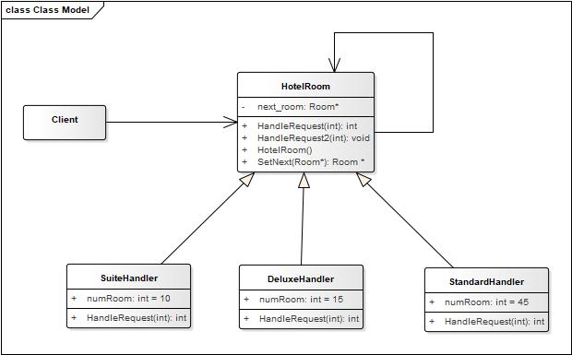

# 

# Screenshots of Output Scenarios

Being able to enter bid that fit into all hotel room types



Outside of bid range



Show statements that prove the process of going through each handler

